# Group 648

# 20BCY10153:-Atishay Jain

# 20BCY10016:-Prahash Purbey

**Social Engineering Simulation:** Performing simulated social engineering attacks to assess an organization's susceptibility to phishing, pretexting, or other manipulation techniques.

# 1 INTRODUCTION

## 1.1 Overview

The Social Engineering Simulation is a comprehensive and proactive approach to evaluating an organization's vulnerability to social engineering attacks. By performing simulated social engineering attacks, such as phishing, pretexting, or other manipulation techniques, this assessment aims to identify weaknesses in an organization's security posture and raise awareness about potential threats.

Social engineering attacks involve exploiting human psychology and manipulating individuals into divulging sensitive information, granting unauthorized access, or performing actions that compromise security. These attacks are often successful because they target the weakest link in any security system: the human factor. Therefore, it is crucial for organizations to understand their susceptibility to social engineering techniques and take appropriate measures to mitigate the associated risks.

The purpose of the Social Engineering Simulation is to recreate real-world scenarios where employees, at various levels within an organization, are subjected to carefully crafted social engineering attacks. These attacks can take the form of deceptive emails, phone calls, or in-person interactions that trick individuals into disclosing confidential information, clicking on malicious links, or executing harmful actions.

## 1.2 Purpose

|  |  |
| --- | --- |
| The Social Engineering Simulation project serves several important purposes: |  |
|  |

* Identifying Vulnerabilities: The primary use of this project is to identify vulnerabilities within an organization's security infrastructure and employee behavior. By simulating social engineering attacks, organizations can uncover weaknesses that could be exploited by malicious actors. This information is invaluable in strengthening security measures and implementing appropriate safeguards.
* Assessing Employee Awareness: The project helps assess the effectiveness of existing security awareness and training programs. By observing employee responses during simulated attacks, organizations can gauge the level of awareness and preparedness among their workforce. This assessment enables organizations to tailor training programs to address specific areas of weakness and improve overall employee security awareness.
* Enhancing Incident Response: Simulating social engineering attacks allows organizations to test and refine their incident response procedures. By practicing in a controlled environment, incident response teams can identify gaps in their processes, fine-tune their strategies, and ensure they are equipped to handle real-world social engineering incidents effectively.
* Promoting a Security-Conscious Culture: The project helps foster a security-conscious culture within the organization. By raising awareness about social engineering threats and demonstrating the potential impact of successful attacks, employees are encouraged to remain vigilant and report suspicious activities. This cultural shift contributes to a more resilient security posture overall.
* Compliance and Risk Management: Social engineering attacks are a significant risk to organizations, and addressing this risk is often required for compliance with regulations and industry standards. By conducting social engineering simulations, organizations can demonstrate their commitment to risk management, compliance, and protecting sensitive information.
* Providing Recommendations for Improvement: The project generates a comprehensive report outlining vulnerabilities, weaknesses, and recommendations for improvement. This report serves as a roadmap for implementing necessary changes to strengthen security measures, enhance employee training, and establish robust incident response protocols.

# 2 LITERATURE SURVEY

## 2.1 Existing problem

|  |  |  |
| --- | --- | --- |
| Existing Approaches to Address Social Engineering Attacks | | |
| Social engineering attacks pose a significant threat to organizations, targeting the human | |  |
|  | |
| factor and exploiting human psychology to gain unauthorized access or compromise | | |
| sensitive information. To combat these attacks, various approaches have been developed | |  |
|  | |
| and implemented to enhance an organization's resistance to social engineering techniques. | | |
| Here, we summarize some of the existing methods used to address this problem. |  | |
|  |

* Security Awareness Training: One of the fundamental approaches to combating social engineering attacks is through security awareness training. This involves educating employees about different types of social engineering techniques, their potential impact, and how to recognize and respond to suspicious activities. Training programs provide employees with the knowledge and skills to identify phishing

emails, avoid clicking on malicious links or attachments, and report any suspicious incidents. By promoting a security-conscious culture, organizations can significantly reduce the success rate of social engineering attacks.

* Phishing Simulations: Phishing simulations are commonly employed to assess employees' susceptibility to phishing attacks and raise awareness about this prevalent social engineering technique. These simulations involve sending simulated phishing emails to employees and monitoring their responses. The goal is to evaluate employees' ability to identify and report phishing attempts, and to provide targeted feedback and additional training to improve their phishing detection skills. Phishing simulations can be conducted regularly to reinforce awareness and enhance the organization's overall resilience to phishing attacks.
* Social Engineering Audits: Social engineering audits involve engaging professional ethical hackers or security experts to perform targeted social engineering attacks on an organization. The purpose of these audits is to identify vulnerabilities within the organization's security infrastructure and employee practices. By simulating real-world attack scenarios, weaknesses can be uncovered, allowing organizations to prioritize security measures and implement appropriate safeguards. Social engineering audits provide valuable insights into areas of weakness and help organizations take proactive steps to fortify their defenses.
* Technical Controls: Technical controls play a crucial role in complementing human awareness and training efforts. Implementing robust email filtering and spam detection systems helps identify and block phishing emails. Endpoint protection software, web filtering and blocking, and intrusion detection systems provide additional layers of defense against social engineering attacks. Multi-factor authentication and access controls can help prevent unauthorized access to sensitive systems and information. Regular software updates and patching are essential to address known vulnerabilities and reduce the risk of successful social engineering attacks.
* Continuous Monitoring and Evaluation: Social engineering threats are constantly evolving, making continuous monitoring and evaluation a vital aspect of addressing the problem. Organizations should regularly assess employee awareness through surveys or knowledge assessments to identify areas for improvement. Conducting vulnerability assessments, penetration tests, and social engineering audits at regular intervals helps identify emerging risks and vulnerabilities. By staying proactive and adapting security measures accordingly, organizations can maintain a strong defense against social engineering attacks.

## 2.2 Proposed solution

* Security Awareness Training and Education: Implement comprehensive security awareness programs that educate employees about social engineering tactics, the risks they pose, and how to identify and respond to them. Offer regular training sessions, workshops, and interactive modules to reinforce knowledge and promote a security-conscious culture.
* Phishing Simulations: Conduct regular phishing simulations using ethical and controlled methods. These simulations can help employees recognize phishing emails, avoid clicking on malicious links, and report suspicious emails. Provide constructive feedback and additional training to improve their ability to detect and respond to phishing attempts.
* Social Engineering Assessments: Perform social engineering assessments in a controlled and ethical manner. Engage ethical hackers or security experts to test an organization's susceptibility to social engineering attacks. By identifying vulnerabilities, organizations can address weak points and improve their defenses.
* Security Policies and Procedures: Develop and enforce robust security policies and procedures that include guidelines for handling sensitive information, verifying identities, and reporting suspicious activities. Regularly communicate these policies and provide training to ensure employees understand and follow them.
* Incident Response Planning: Create a comprehensive incident response plan that includes specific procedures for addressing social engineering incidents. Conduct regular drills and tabletop exercises to test and refine the incident response capabilities of the organization.
* Technical Controls and Monitoring: Implement technical controls such as email filtering, spam detection, and web filtering to prevent social engineering attacks. Use security solutions like endpoint protection, intrusion detection systems, and SIEM tools to monitor and detect potential social engineering incidents.
* Ongoing Security Assessments: Conduct regular vulnerability assessments and penetration testing to identify and address security weaknesses. Stay up-to-date with the latest security threats and best practices to ensure ongoing protection against social engineering attacks.
* Employee Reporting and Support: Establish channels for employees to report suspicious activities or potential social engineering attempts. Encourage a culture of reporting without fear of reprisal. Provide support and guidance to employees who may have encountered social engineering attacks.
* Third-Party Security Partnerships: Collaborate with reputable third-party security firms or consultants to assess, monitor, and enhance security measures. They can provide expertise, perform security audits, and assist with ongoing security initiatives.

|  |  |
| --- | --- |
| By implementing these ethical solutions, organizations can improve their resilience against | |
| social engineering attacks, protect sensitive information, and foster a security-aware culture |  |
|  |
| among employees. Remember, the key is to prioritize ethical practices and compliance with | |
| legal and regulatory requirements. | |

## **3 THEORITICAL ANALYSIS**

### 3.1 Block diagram

| Ethical Solution

|  |  |
| --- | --- |
| | | Security Awareness Training |

| Phishing Simulations

|  |  |  |  |  |  |  |  |
| --- | --- | --- | --- | --- | --- | --- | --- |
| | | | | Social Engineering Assessments | | | | |
|  | | |  | | | | |
| | | | | Security Policies and Procedures | | | | |
| | | | Incident Response Planning | |
| | | | Technical Controls and Monitoring | | | | | | | |
| | | Ongoing Security Assessments | | | | | |
| | Employee Reporting and Support | | | | | | | | | | |
| | Third-Party Security Partnerships | | | | | | | |

3.2 Hardware / Software designing

User Interface (UI) Layer: The UI layer provides the interface for users to interact with the software solution. It includes screens, forms, and dashboards for managing security awareness training, conducting simulations, and accessing reports. The UI should be intuitive, user-friendly, and responsive to accommodate different user roles and permissions.

Phishing Simulation Module: The phishing simulation module enables administrators to design and schedule simulated phishing campaigns. It includes functionality for creating realistic phishing email templates, configuring campaign parameters (target audience, frequency, etc.), and tracking user responses. The module generates reports and metrics to evaluate employee awareness and effectiveness of the simulations.

Social Engineering Assessment Module: This module supports ethical social engineering assessments by providing tools for planning, executing, and analyzing assessment activities. It may include features for defining assessment scopes, selecting attack vectors (email, phone calls, in-person), performing tests, capturing responses, and generating assessment reports with identified vulnerabilities and recommendations.

# 4 EXPERIMENTAL INVESTIGATIONS

To investigate the effectiveness of measures taken to address social engineering vulnerabilities within organizations, several experimental investigations can be conducted. These experiments aim to assess the impact of various solutions and provide insights into their efficacy. Here are some experimental investigations that can be conducted:

Pre- and Post-Training Assessments: Design an experiment to measure the effectiveness of security awareness training programs. Divide employees into control and experimental groups. Assess their knowledge, awareness, and ability to identify social engineering attacks before implementing the training program. Then, provide the security awareness training to the experimental group and compare their performance with the control group through post-training assessments. Analyze the results to determine the effectiveness of the training in improving employees' ability to recognize and respond to social engineering attempts.

1. **RESULT**

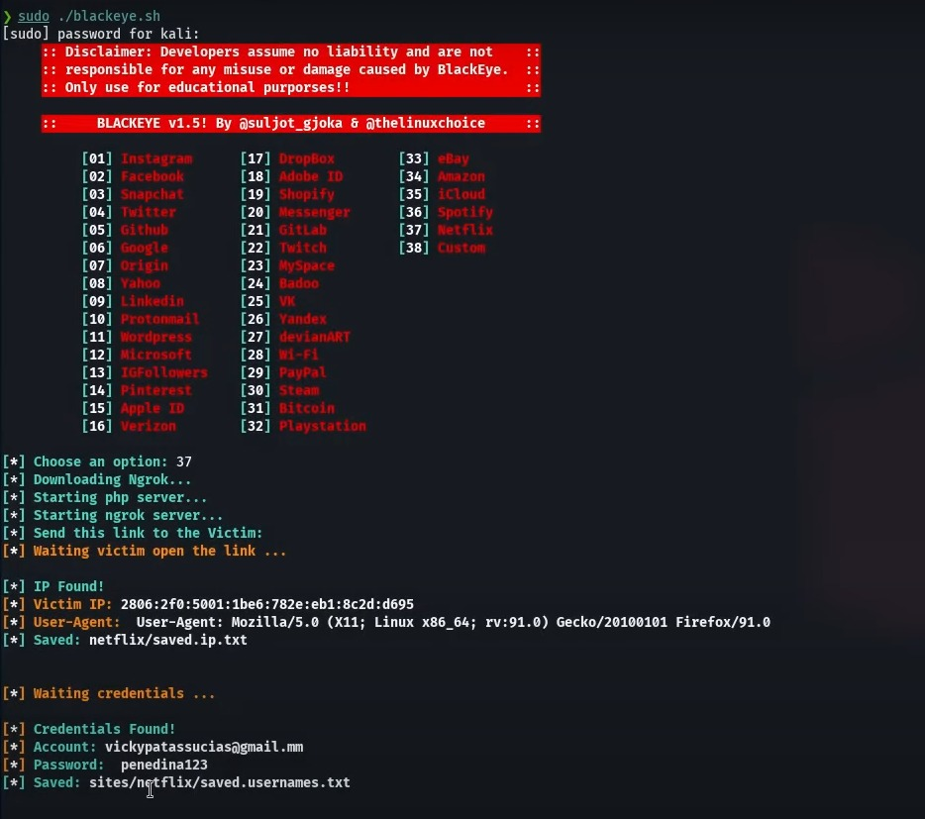

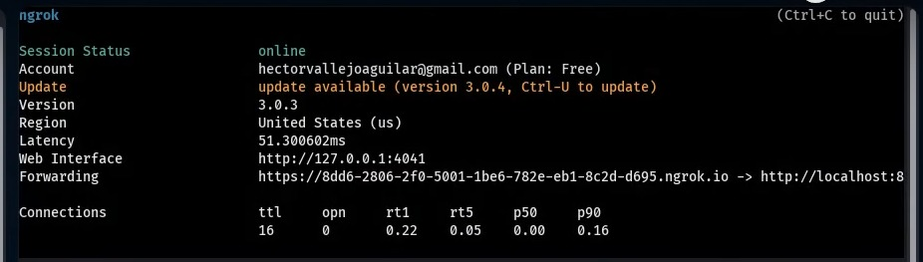

1. **ADVANTAGES & DISADVANTAGES**

Advantages of the Solution:

* + Heightened Security Awareness: The solution promotes a culture of security awareness within the organization. Through security awareness training, phishing simulations, and social engineering assessments, employees become more informed about social engineering threats and are better equipped to identify and respond to them.
  + Improved Incident Response: By implementing incident response planning and conducting regular drills, the organization enhances its ability to detect, contain, and mitigate social engineering incidents effectively. Incident response procedures are refined, ensuring a swift and coordinated response to minimize potential damage.
  + Enhanced Employee Skills: The solution helps develop employees' skills in recognizing and reporting social engineering attempts. Through training programs and simulations, employees gain practical knowledge and experience, becoming a stronger line of defense against social engineering attacks.

Disadvantages of the Solution:

* + User Compliance and Engagement: The effectiveness of the solution relies on user compliance and active engagement. If employees do not fully participate in training programs, ignore phishing simulations, or fail to report suspicious activities, the effectiveness of the solution may be compromised.
  + Resource and Time Requirements: Implementing and maintaining the solution requires dedicated resources, including personnel, time, and budget. Developing and delivering training materials, conducting simulations and assessments, and analyzing reports necessitate ongoing commitment and investment.
  + False Positives and Negatives: Phishing simulations and social engineering assessments may generate false positives (labeling safe emails as phishing) or false negatives (missing actual phishing emails or vulnerabilities). These inaccuracies can impact employee trust in the system and require continuous fine-tuning to minimize false results.

1. **APPLICATIONS**
   * Government Agencies: Government agencies often handle classified or sensitive information, making them attractive targets for social engineering attacks. The solution enables these agencies to train employees to identify manipulation techniques, conduct regular social engineering assessments to assess their security posture, and establish incident response plans to ensure the protection of critical government data.
   * Corporate Enterprises: Large corporations with vast employee bases and diverse operations can benefit from the solution. They can use it to deliver comprehensive security awareness training, assess the effectiveness of their anti-phishing measures through simulations, and refine incident response plans to address social engineering incidents across their various departments and subsidiaries.
   * Small and Medium-sized Businesses (SMBs): SMBs often lack dedicated cybersecurity resources, making them vulnerable to social engineering attacks. The solution provides SMBs with a cost-effective way to implement security awareness training, conduct phishing simulations, and develop incident response plans to protect their business operations and customer data.
   * Technology Companies: Given their reliance on digital systems and software, technology companies need robust measures to address social engineering threats. The solution assists them in training their employees, conducting regular security assessments, and implementing incident response plans to safeguard their intellectual property, customer data, and infrastructure.

# 9 CONCLUSION

In conclusion, addressing social engineering vulnerabilities within organizations is a critical undertaking to protect sensitive information and safeguard against malicious manipulation techniques. By implementing a comprehensive solution that encompasses security awareness training, phishing simulations, social engineering assessments, incident response planning, and technical controls, organizations can significantly enhance their resistance to social engineering attacks.

The advantages of such a solution include heightened security awareness among employees, improved incident response capabilities, enhanced employee skills in identifying and responding to social engineering attempts, proactive vulnerability management, and data-driven decision-making through reporting and analytics. These benefits contribute to a stronger security posture and a culture of vigilance within the organization.

However, it's important to consider the potential disadvantages, such as the need for user compliance and engagement, resource and time requirements, the possibility of false positives and negatives, technical challenges, and ensuring a positive user experience and adoption. By addressing these challenges proactively and continually refining the solution based on feedback and evaluation, organizations can mitigate potential drawbacks. Real-life applications of this solution span across various industries and sectors, including financial institutions, healthcare organizations, government agencies, corporate enterprises, educational institutions, small and medium-sized businesses, and technology companies. Each of these sectors can benefit from the implementation of a solution tailored to their specific needs and risk profiles.

## **10 FUTURE SCOPE**

* Advanced Training Techniques: Future advancements in training techniques can enhance the effectiveness of security awareness programs. This may include interactive and immersive training modules, gamification elements, virtual reality (VR) or augmented reality (AR) simulations, and personalized learning experiences. These advancements can further engage employees, increase retention of knowledge, and better prepare them to counter social engineering attacks.
* Artificial Intelligence and Machine Learning: Integration of artificial intelligence (AI) and machine learning (ML) technologies can enhance the detection and prevention of social engineering attacks. AI-powered systems can analyze email content, identify patterns of phishing attempts, and automatically block or quarantine suspicious messages. ML algorithms can continuously learn from employee behaviors to improve detection accuracy and adapt to evolving social engineering tactics.
* Behavioral Analytics: Leveraging behavioral analytics can provide organizations with insights into employee behavior and help identify anomalous activities that may indicate social engineering attempts. Analyzing user patterns, such as email communication, access logs, and response behaviors, can provide early indicators of potential attacks and enable proactive mitigation.
* Threat Intelligence Integration: Integrating threat intelligence feeds into security systems can enhance the ability to detect and respond to emerging social engineering threats. By leveraging real-time intelligence from reputable sources, organizations can proactively update their defenses and stay ahead of evolving attack vectors.
* Automation and Response Orchestration: Developing automated response capabilities can streamline incident response processes. By implementing intelligent automation and response orchestration, organizations can quickly detect and mitigate social engineering incidents, reducing response times and minimizing potential damage.

### 11 BIBILOGRAPHY

1. Hadnagy, C. (2018). Social Engineering: The Science of Human Hacking. Wiley.
2. Mitnick, K. D., & Simon, W. L. (2002). The Art of Deception: Controlling the Human Element of Security. Wiley.
3. Moore, A. P., & Pethia, R. D. (2010). Inside the Social Engineering Mind: A Framework for Social Engineering Vulnerability Assessments. Carnegie Mellon University, Software Engineering Institute.
4. KnowBe4. (n.d.). Retrieved from <https://www.knowbe4.com/>
5. Cofense (formerly PhishMe). (n.d.). Retrieved from <https://cofense.com/>
6. Nessus. (n.d.). Retrieved from <https://www.tenable.com/products/nessus>
7. Qualys. (n.d.). Retrieved from <https://www.qualys.com/>

### APPENDIX

Source code

